Hello David,

So sorry for the delay in getting this email to you. Thank you for our call on Friday.

As discussed, TeleMessage is seeking a partner for our “[Archive Text Messaging](https://www.telemessage.com/secure-text-messaging/sms-archiving/)” solution. The solution covers several archiving scenarios and is based on Secure Mobile Applications, Virtual Business Number options and Network Archiving options.  The solutions are customized for the needs of the customer. The Secure Mobile and Virtual Business Number options are the only options that work across all carriers in all countries but do require our mobile applications which are branded either for you or your customer. The Network Archiving options work only in the US and only for selected carriers. Sprint, AT&T and Verizon will all be completed this year. You can see the Virtual Business Number option below:

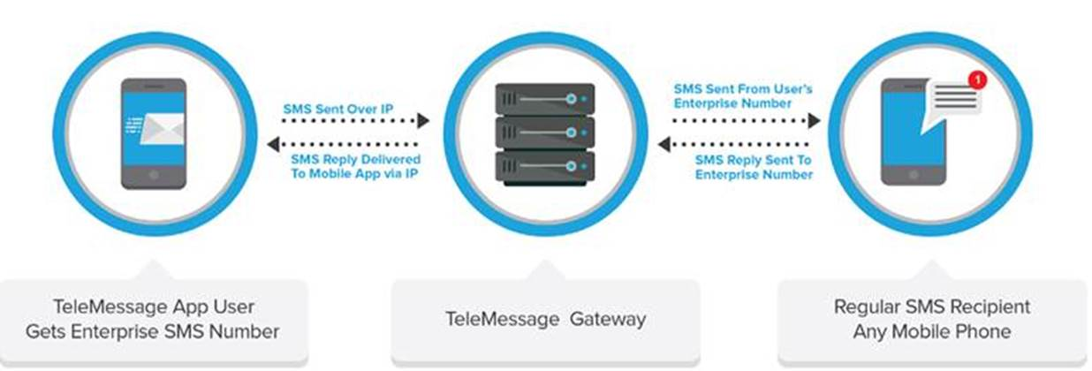

TeleMessage brings 17 years of experience in deploying solutions for Tier1 telecom carriers, Fortune 500 companies, and government agencies. Some of our customers include Verizon Wireless, Sprint, Rogers Wireless, Capital One Bank and many more.

With the tremendous growth in mobile text archiving, we believe teaming with you offers a lot of synergy for both parties.

**Regards,**

**Mark Carlin |** VP of Sales Americas

**Mobile:** [617-320-4422](tel:617-320-4422) **| Office:** 978-263-1015 X224 **| Fax:** [978-263-6467](tel:978-263-6467)

**E-mail:** [mcarlin@telemessage.com](mailto:mcarlin@telemessage.com) **| Web:** [www.TeleMessage.com](http://www.telemessage.com/)

**TeleMessage is** [**Transforming Business Mobile Messaging**](http://www.telemessage.com/)

[Start a Free Trial](http://www.telemessage.com/newjsp/marketing/signup.jsp?usertype=911&campaignID=Email-Signature) **|** [Watch a  short demo!](https://www.youtube.com/embed/erW-JF_YQ34) **|** [Try our APIs](http://developer.telemessage.com/)