Subject: Request for intro to ZL Technologies

TeleMessage is seeking to partner with ZL Technologies for our “Archive Text Messaging” solution.
Our solution is based on our “Secure Mobile Application” and in addition a “Virtual Number” as you can see below:

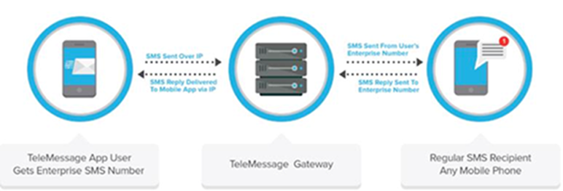

TeleMessage brings 17 years of experience in the deploying solutions for Tier1 telecom carriers, Fortune 500 companies, and government agencies.
Some of our customers include Verizon Wireless, Sprint, Rogers Wireless, Capital One Bank and many more (see example of Sprint : https://sem.sprint.com/secure-enterprise-messenger/ )

With the tremendous growth in mobile text archiving, we believe teaming with ZL Technologies offers a lot of synergy for both parties. We see some of your competitors have adopted/developed similar solutions to ours.

Guy Levit | Chief Executive Officer
Mobile: +972-54-444-9951 | Direct: +972-77-9211-902
USA: +1 978-795-4117 | Office: +972-3-922-5252
E-mail: guy@telemessage.com | Web: www.TeleMessage.com

TeleMessage is Transforming Business Mobile Messaging
Start a Free Trial | Watch a short demo! | Try our APIs

